Week 6 Homework
6) Proportions new medication
Pain Relief- 44/120=0.3666=0.367
No Pain Relief-76/120=0.633=0.633
Proportions placebo
Pain Relief- 21/120=0.175
No Pain Relief-9/120=0.825
Formula: 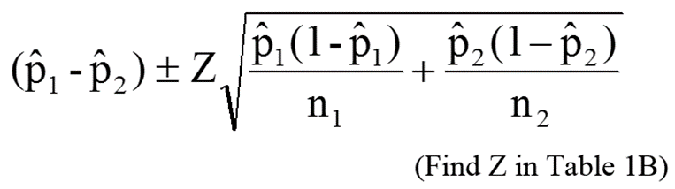
New Medication: (0.367-0.633) +/- 1.96 sqroot 0.367(1-0.367)/120 + 0.633(1-0.633)/120
Sqroot 0.001898 +0.001932935 =0.003833925
Sqroot=0.0619
(0.367-0.633)= 1.96*0.0619=0121324 round up 0.121
-0.266=+/- 0.121= -0.145 or -0.387 they are not statistically the same.

Placebo(0.175-0.825) +/- 1.96 sqroot 0.175(1-0.175)/120 +0.825(1-0.825)/120
-0.65 +/- 1.96 sqroot 0.001203125 + 0.001203125=0.049053542 round up 0.0491
-0.65 +/- 0.096736 round up to 0.096=
-0.0554/0.746

8a) 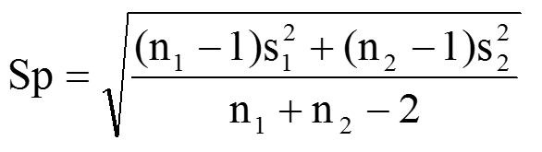
Sp= sqroot (100-1)(15.4)² +(100-1)(18.9)²/100+100-2
Sqroot 23478.84 +35363.79 =58842.63/198= 297.185
=17.24

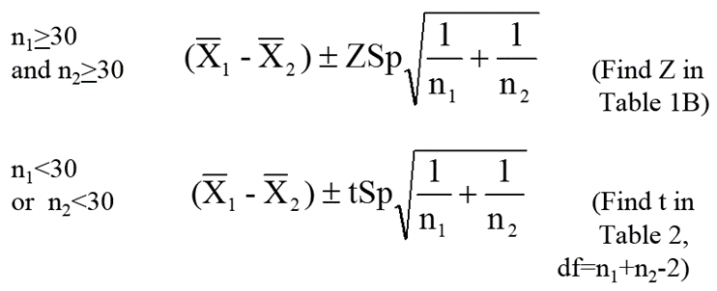 the formula used is the top formula based the sample size

(120.2-131.4) +/-1.96(17.24) sqroot 1/100 +1/100
-11.2 +/- 33.790(0.141)
-11.2 +/-4.7
-15.9 +/- 6.5
8b) Test Proportions
(group 1)14/100= 0.14 (group 2) 22/100=0.22
(0.14-0.22)+/-(1.96) sqroot (0.14(1-0.14)/100 +0.22(1-0.22)/100
-0.08 +/- (1.96) sqroot 0.001204 +0.001716= 0.010584
-0.08 +/-0.10584 =
-0.02584/ 0.18584
Not enough data to say they are different

15)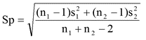
Sp=sqroot (50-1)(24.5)² + (75-1)(21.6)²/50+75-2=
Sqroot 29412.25 +34525.44/123=22.799=22.80

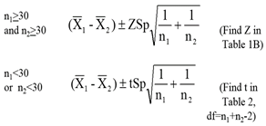 the formula used is the top formula based the sample size

(225.4-203.8) +/- 1.96 (22.80) sqroot 1/50 +1/75=
21.6 +/-1.96(22.80)(0.18)=
21.6 +/-8.0442 round up to 8.04
29.64 / 13.56
Low carbohydrate diet has a higher cholesterol level than Conventional diet

